HCI Project:

School Management System

Project Members:

Abdullah Tilal 19k-1103

Sadeem Sattar 19k-1102

Salman Ahmed Khan 19k-1043

Design Rationale

The model used is QOC

The questions are written and below them in bullet point Options are available corresponding with their criteria which include either pro or cons and their brief details.

What will be the color contrast?

* Negative contrast: Easy for user to view the windows form and effective user display.
* Positive contrast: Every items and elements in form will look similar and difficult for user to differentiate.

Contrast Selected: Negative contrast. 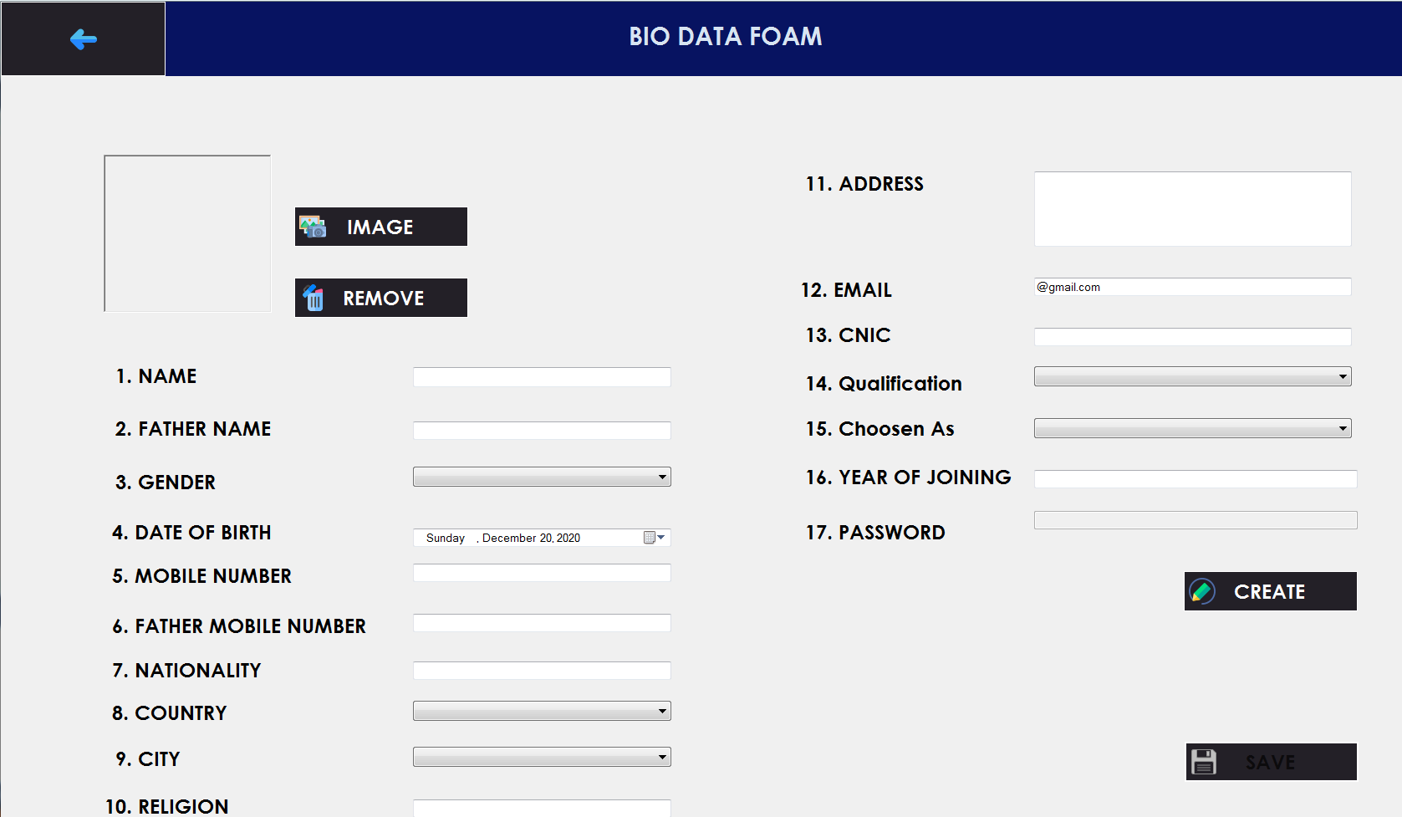

What is the button will look like?

* Rectangle form: Easy for user to click on the button and reduce the time of the user in order to drag the mouse and click.
* Circular form: Minimize the space on the windows form and maximize the user time in order to drag the mouse and click.

Button Selected: Rectangle form

How the main menu will be presented to the user?

* Horizontal Menu Panel: All the functionalities will be placed on the panel horizontally thus create horizontal menu panel. The more functionality, the more compressed look. Also, user might get distracted from it
* Vertical Menu Panel: All the functionalities will be placed on the panel vertically thus create vertical menu panel. It creates effective display of menus and when clicking on the buttons on the panel, a new page will open which create nice view.

Menu Panel Selected: Vertical Menu Panel

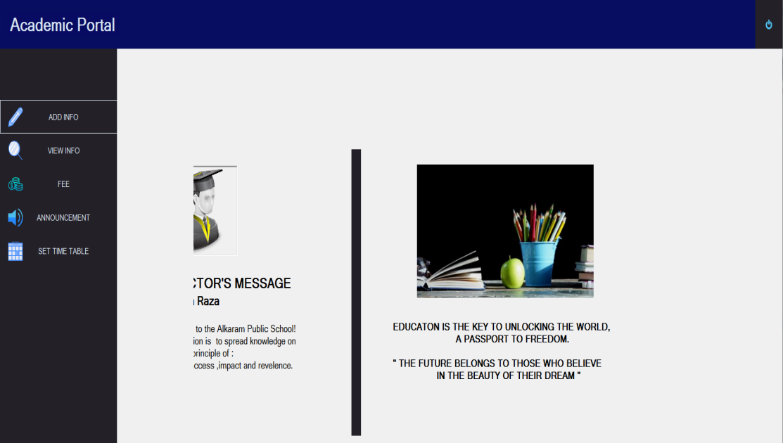

How the font of the text will be?

* Different text fonts: Every font of the text on the individual form will be different from others which will create uniqueness. Also, it will distract user and its interaction will be poor.
* Same text fonts: The fonts of text throughout the system will be consistent which will impact user satisfaction and interaction will be increased.

Font text Selected: Same text fonts



How the user will log in the system?

* Name: It will be unauthenticated to log in the system and security will not be held.
* User name, password and user selection: A particular user name and password will be given to every user and user will select of its option (i.e. Admin, Teacher, Students). Also, security will also be maintained through it and no one can log on anyone else system.

Login Criteria selected: User name, password and user selection.

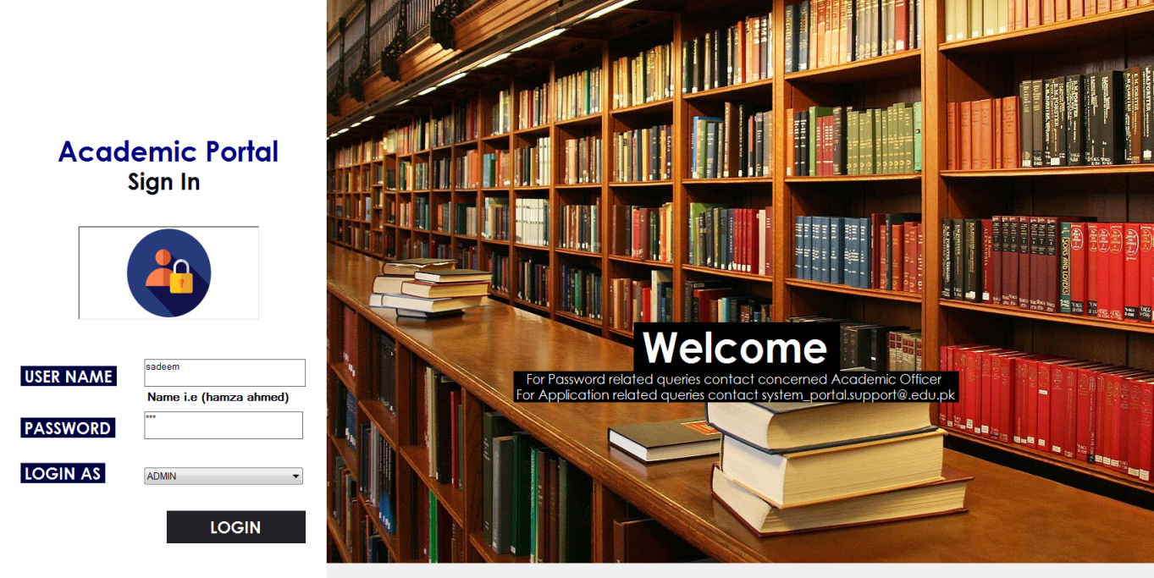

How the Admin will input the information of teacher and students?

* Text box only: The admin can input the information in text box. The user will have to remember what to write and what information is to be saved. It will be time costly and non effective.
* Form based system: The admin can input the information as per the available label and criteria to enter the correct information. The form will include some text box and drop box menus which will be easy to write the information. It will be effective for user.

Input the information selected: Form based system



How the announcement will be added by admin and teacher?

* Pre-defined text selection: A menu box will be given to user in which predefined announcements will be available through which user can select and send to others. This will bound the user and it can not enter any new announcement.
* Textbox: A text box will be presented in which user will enter whatsoever announcement the user want to add and display to the other users. This will give user free to post any announcement and bound it.

Announcement add selected: Text Box

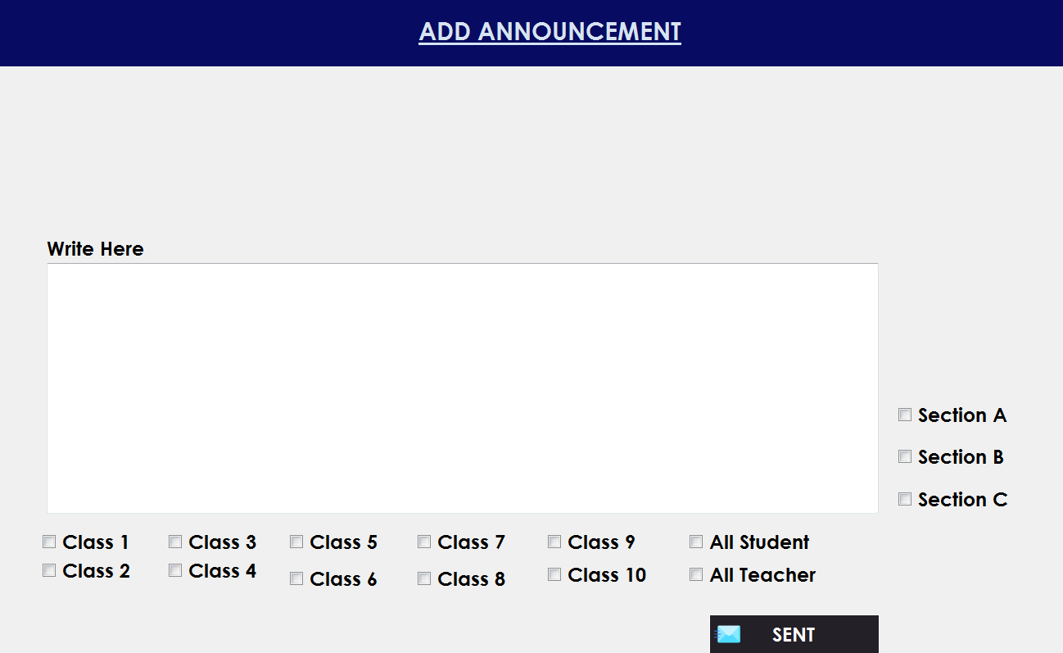

How the Fee challan will be generated?

* Type individual student name and amount in textbox: The user will enter the student name and amount in a textbox through which challan will be generated. It will be time consuming as the user will have to enter every student name and amount of the whole class. Also, user will be needed to do recall remembering whose fee has been generated.
* Select class and section (selection box): The user will select the class and section whose fee is needed to be generated. On selecting, every student detail will be shown. The user will only need to recognize and enter the amount. This is effective as the user can generate the fee for whole the class once.

Fee generation Selected: Selection box

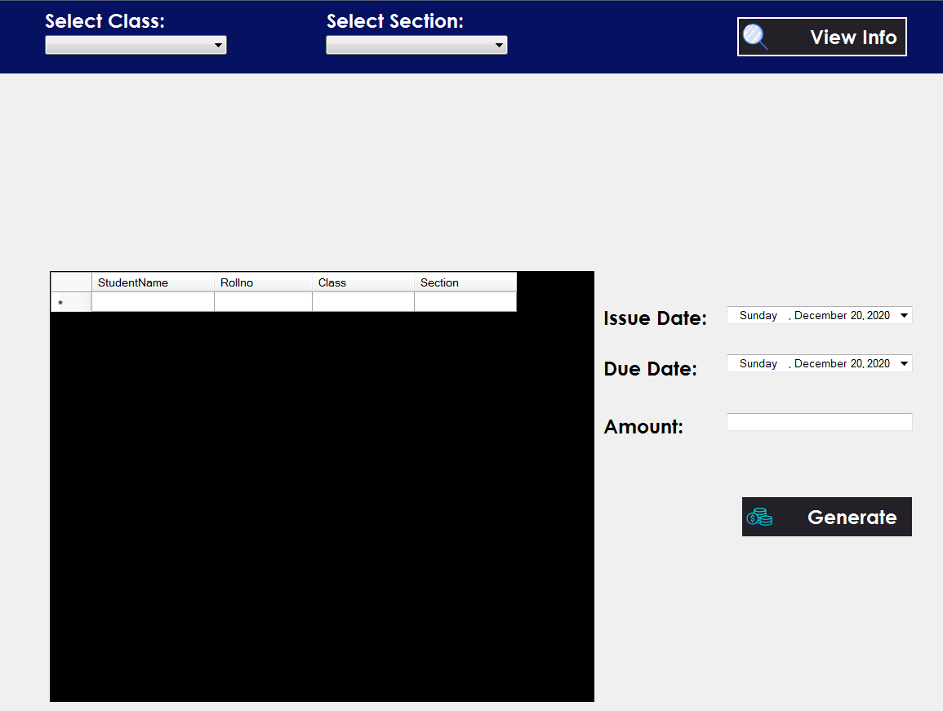

How the timetable will be added?

* Textbox: The user will type the teacher name, class, section, class timing and subject manually in order to add the announcement. This will be time costly and user will have to remember everything.
* Selection box: The user will be presented with the selection box through which user will select the entries. This will be effective and user will have to recognize rather than recall every class name, timing etc.

Selected: Selection box

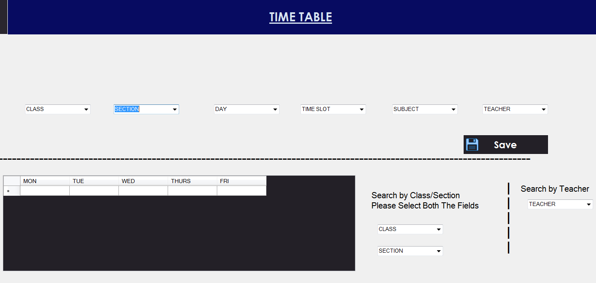

How the user (teacher) will add the attendance of student?

* Select individual: The user will have to select every individual student name and then mark the attendance. This will require user to do the task multiple time and the interaction will be poor.
* Select class and section: The user will only select class and section and all the student name and attendance will be displayed simultaneously. The user will only look the student name and mark the attendance of every student. This will reduce user time and the interaction between user and system will become interactive.

Selected: Selection of class and section display

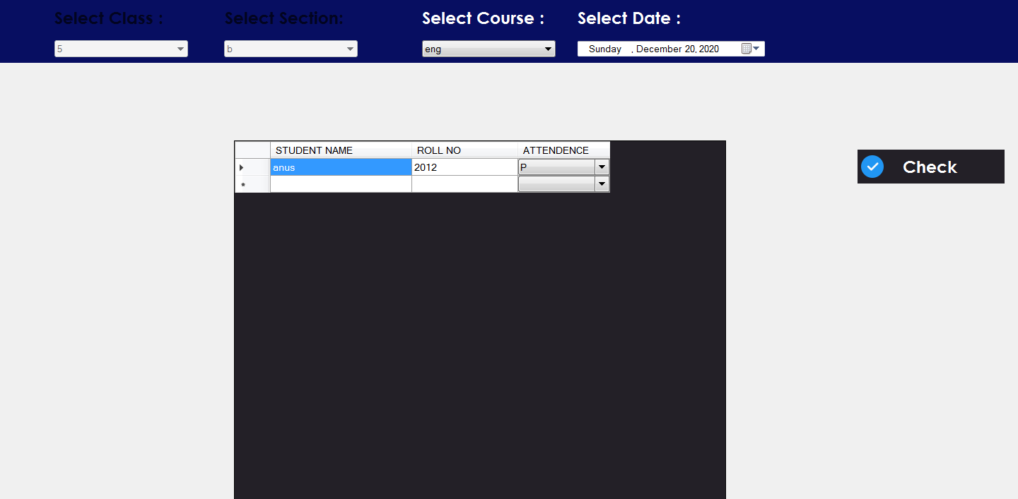

How the user (teacher) will mark the marks of student?

* Select marks range: The user will select the predefined marks from selection box and the exam type, thus add the marks of the students. This will bound the user to select from a range and user will not be able to mark specific marks.
* Type marks: The user can add marks of every individual student. This will allow user to enter the specific marks and user can freely add the marks.

Selected: Type marks

